Descendants of Philipp and Anna Wagner
Get Together – September 2004
Union, KY
Photograph 1 Key
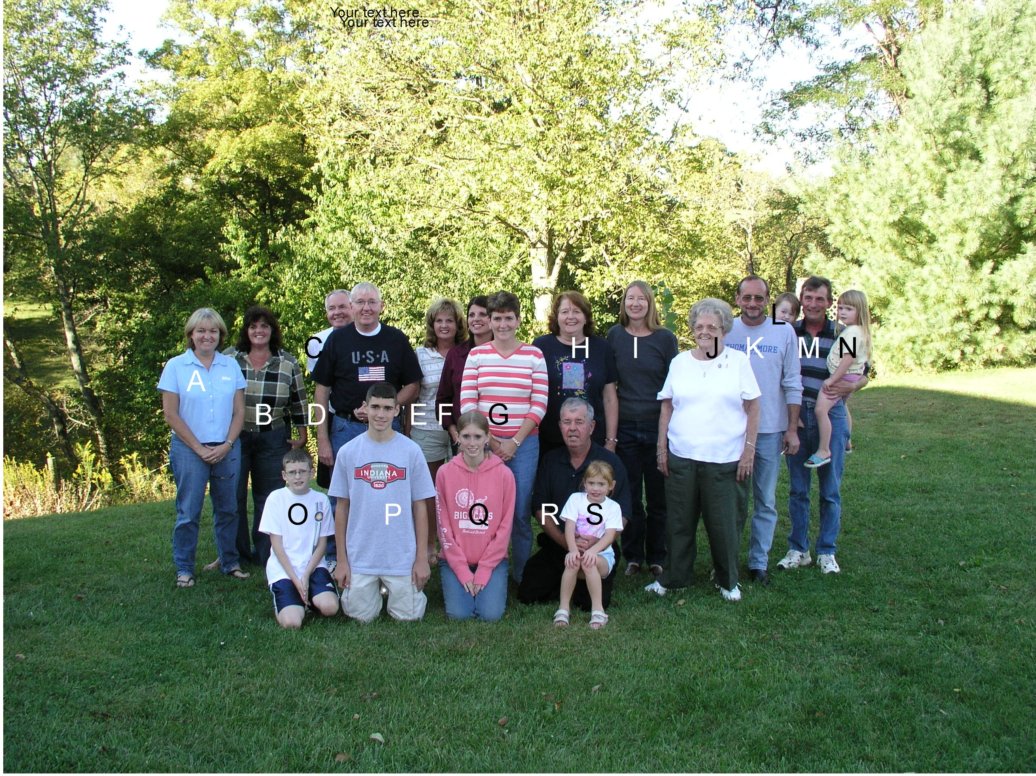
Name | Descendancy Line
A. Catherine Drees-DiBello, Covington, KY | Philipp/Joseph/Rosemary
B. Sylvia (Foltz) Saylor, Independence, KY | Philipp/Joseph/Jane
C. Dennis Joseph Drees, Elsmere, KY | Philipp/Joseph/Rosemary
D. Norbert Joseph Drees, Troy, OH | Philipp/Joseph/Rosemary
E. Mary Jan (Foltz) Kuper, Alexandria, KY | Philipp/Joseph/Jane
F. Rhonda Foltz Reynolds, Florence, KY | Philipp/Joseph/Jane
G. Roseanne (Wagner) Kaiser, Indiana | Philipp/Joseph/Anselm
H. Dianne (Drees) DeMoss, Covington, KY | Philipp/Joseph/Rosemary
I. Martha Miller, Louisville, CO | Philipp/Anna Gertrude Wagner/Catherine Walter
J. Eleanor (Wagner) Overwine, Covington, KY | Philipp/Joseph/Philipp
K. Dan Wagner, Covington, KY | Philipp/Joseph/Anselm
L. Maria Wagner, Union, KY | Philipp/Joseph/Anselm/Joseph
M. Joseph Wagner, Union, KY | Philipp/Joseph/Anselm
N. Hannah Wagner, Union, KY | Philipp/Joseph/Anselm/Joseph
O. Aaron Kaiser, Indiana | Philipp/Joseph/Anselm/Roseanne
P. Andrew Kaiser, Indiana | Philipp/Joseph/Anselm/Roseanne
Q. Alison Kaiser, Indiana | Philipp/Joseph/Anselm/Roseanne
R. Charles Foltz, Florence, KY | Philipp/Joseph/Jane
S. Page __________ Granddaughter of Charles Foltz

