Descendants of Philipp and Anna Wagner
Get Together – September 2004
Union, KY
Photograph 2 Key
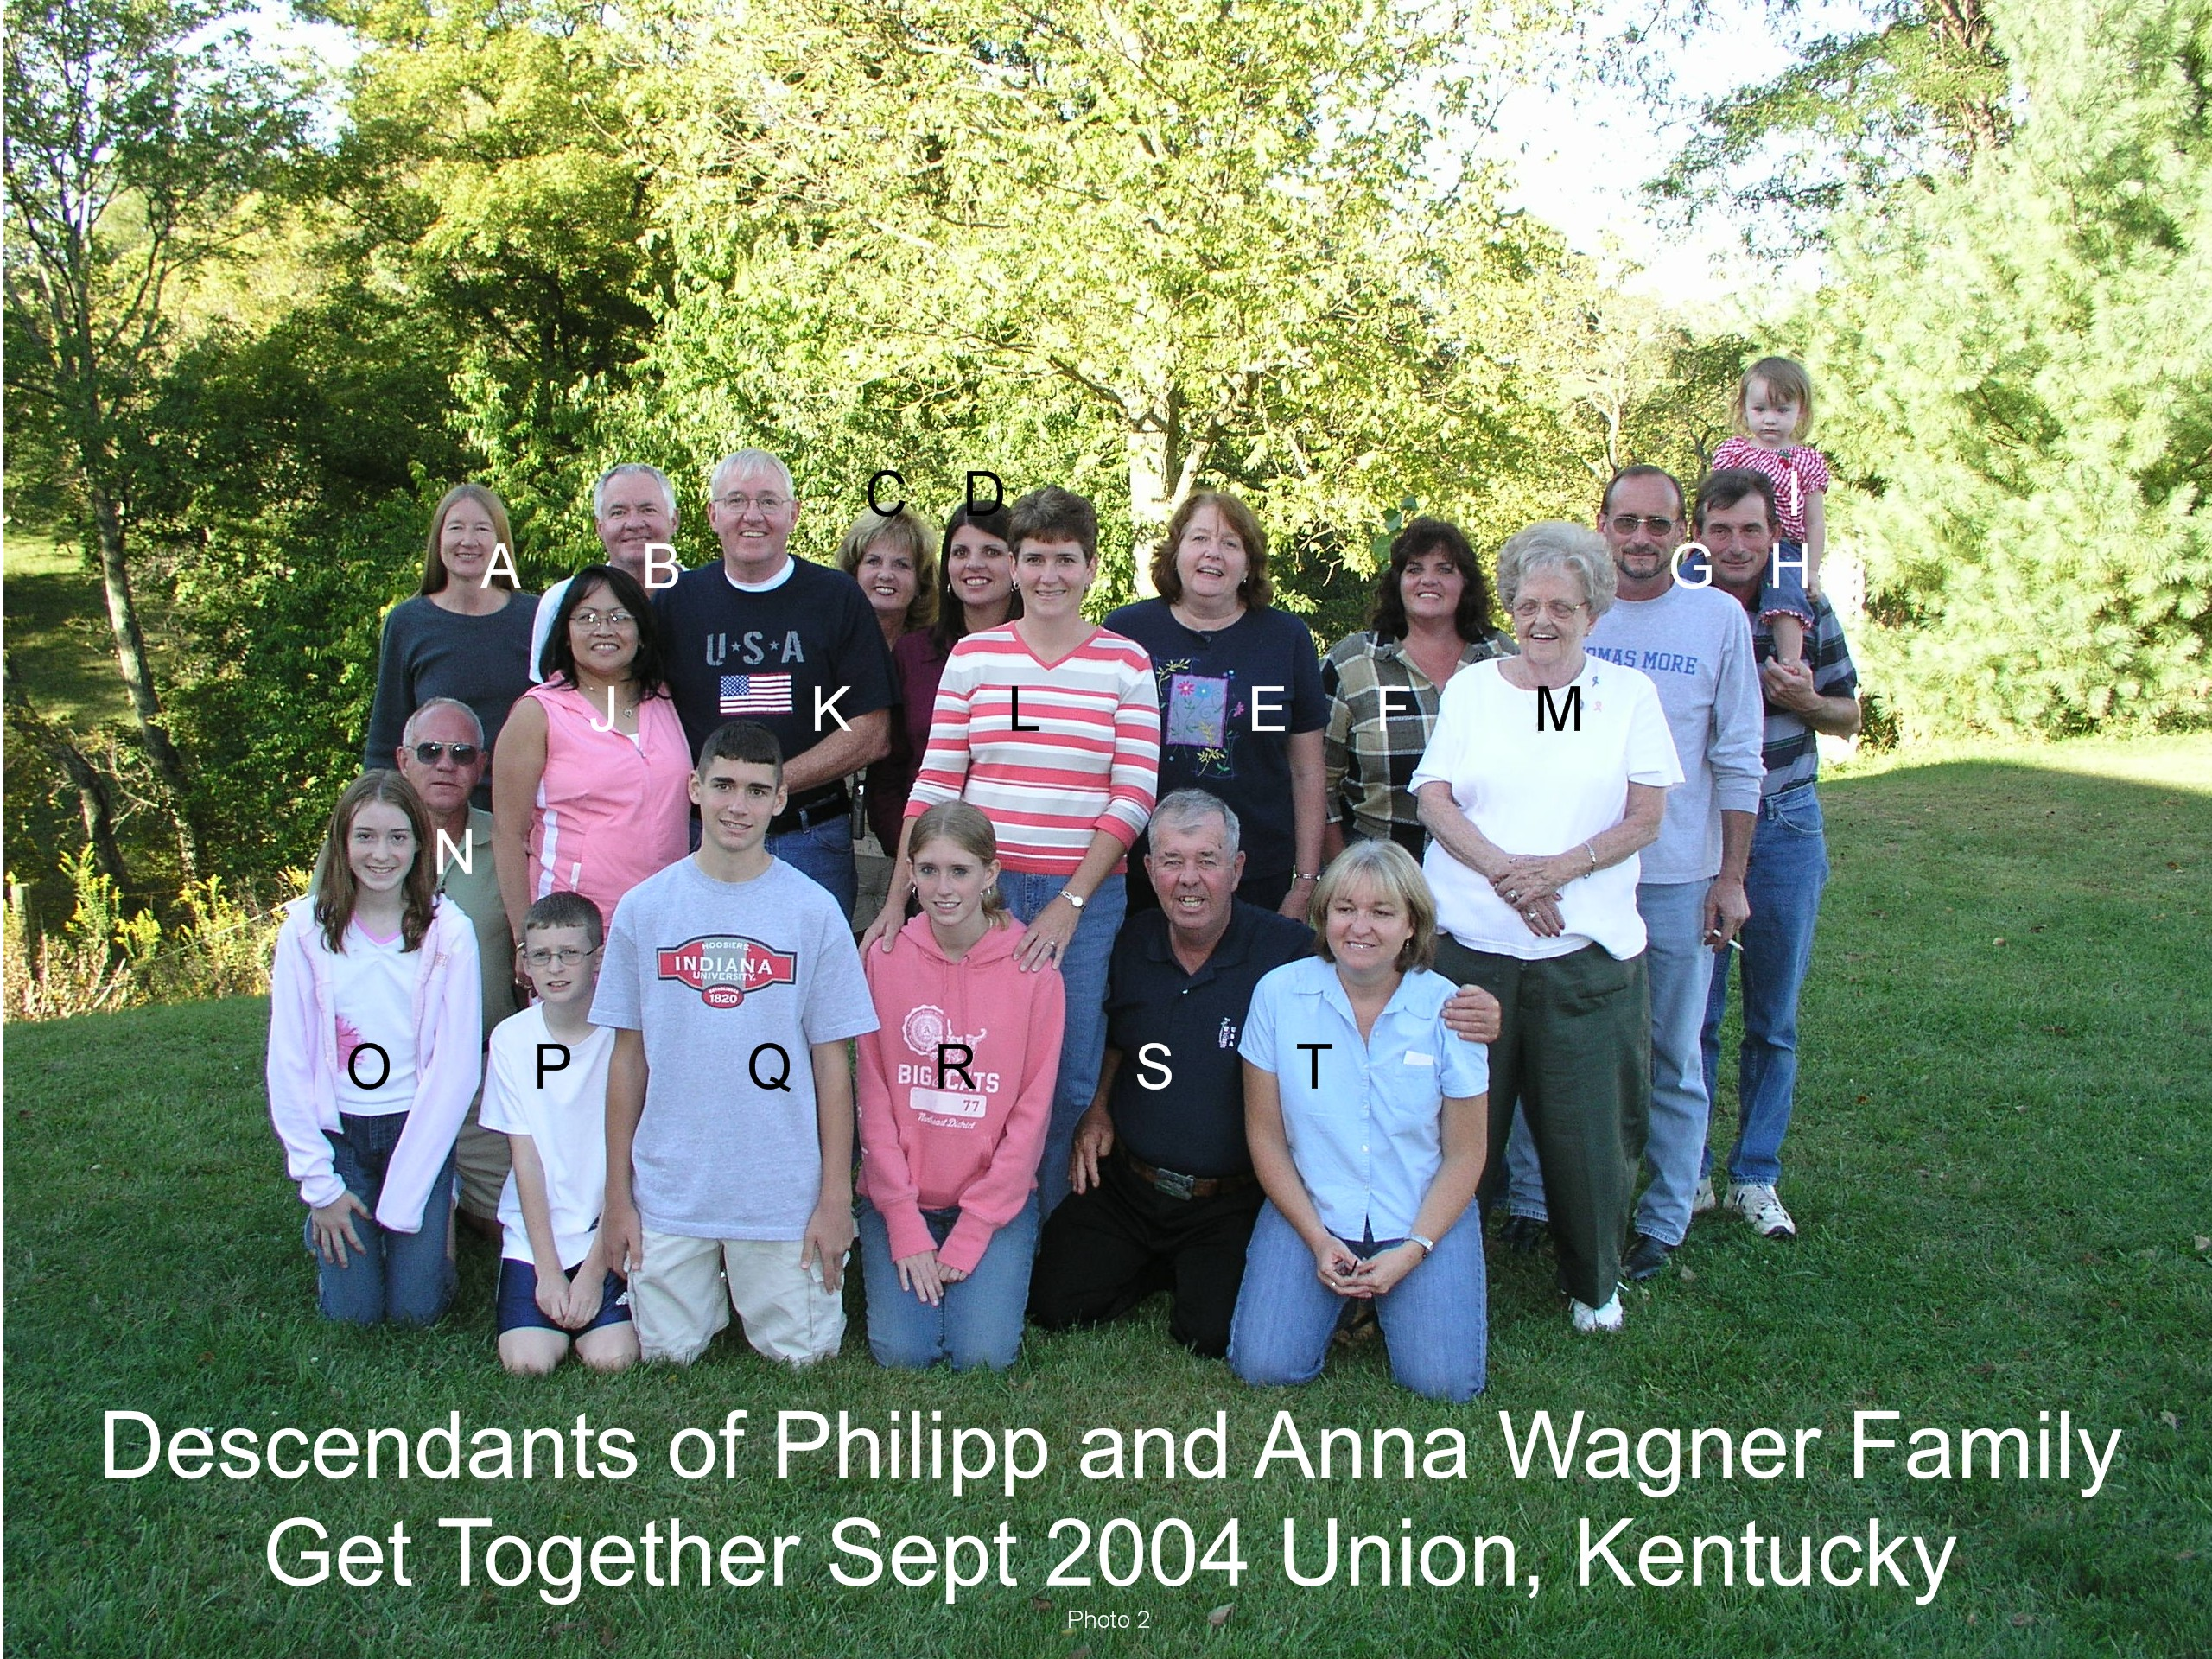

Name | Descendancy Line
A. Martha Miller, Louisville, CO | Philipp/Anna Gertrude Wagner/Catherine Walter
B. Dennis Joseph Drees, Elsmere, KY | Philipp/Joseph/Rosemary
C. Mary Jan (Foltz) Kuper, Alexandria, KY | Philipp/Joseph/Jane
D. Rhonda (Foltz) Reynolds, Florence, KY | Philipp/Joseph/Jane
E. Dianne (Drees) DeMoss, Covington, KY | Philipp/Joseph/Rosemary
F. Sylvia (Foltz) Saylor, Independence, KY | Philipp/Joseph/Jane
G. Dan Wagner, Covington, KY | Philipp/Joseph/Anselm
H. Joseph Wagner, Union, KY | Philipp/Joseph/Anselm
I. Maria Wagner, Union, KY | Philipp/Joseph/Anselm/Joseph
J. Teresita “Tessie” (Cunanan) Drees | Norbert Drees Wife
K. Norbert Joseph Drees, Troy, OH | Philipp/Joseph/Rosemary
L. Roseanne (Wagner) Kaiser, Indiana | Philipp/Joseph/Anselm
M. Eleanor (Wagner) Overwine, Covington, KY | Philipp/Joseph/Phillip
N. Jack Kuper | Husband of Mary Jan Kuper
O. Carolyn Wagner | Philipp/Joseph/Anselm/Joseph
P. Aaron Kaiser, Indiana | Philipp/Joseph/Anselm/Roseanne
Q. Andrew Kaiser, Indiana | Philipp/Joseph/Anselm/Roseanne
R. Alison Kaiser, Indiana | Philipp/Joseph/Anselm/Roseanne
S. Charles Foltz, Florence, KY | Philipp/Joseph/Jane
T. Catherine Drees-DiBello, Covington, KY | Philipp/Joseph/Rosemary

